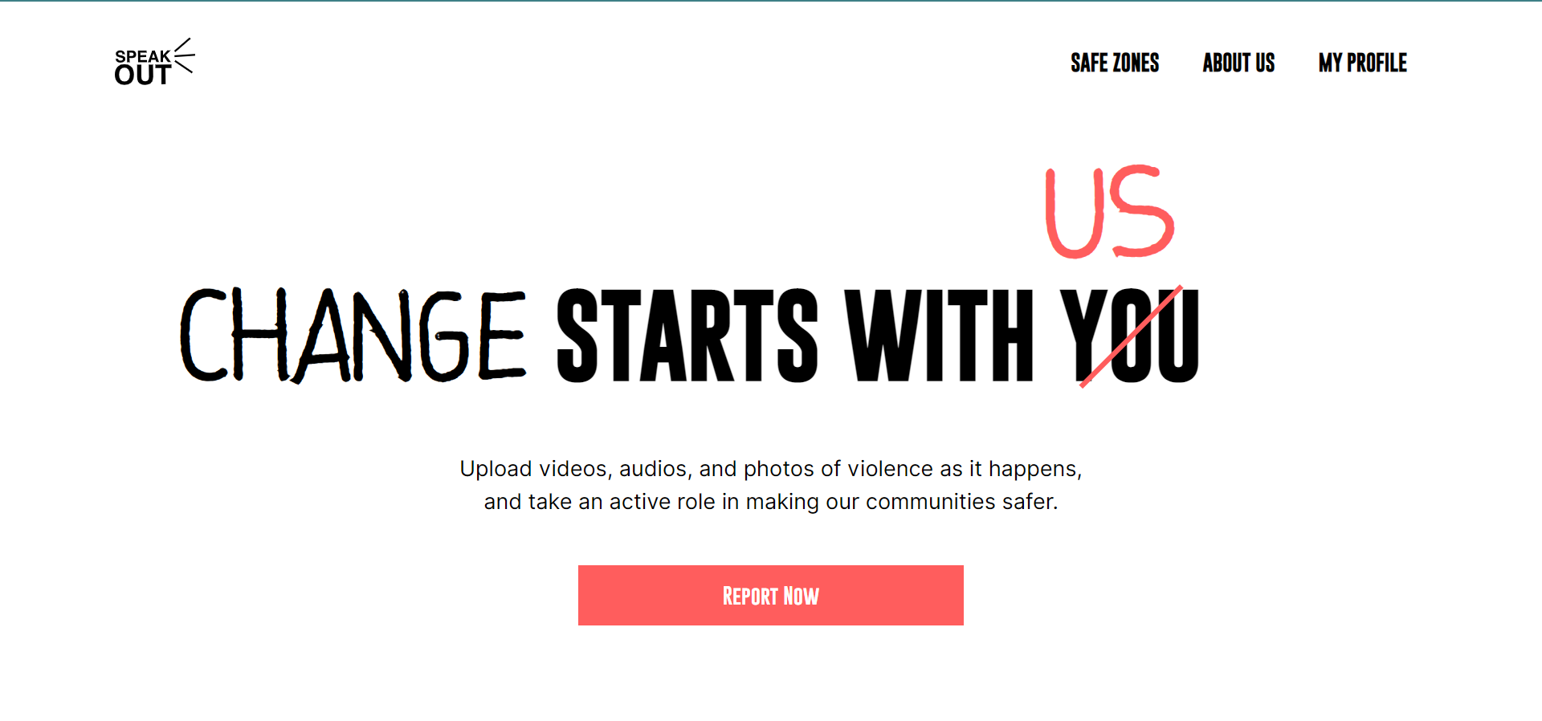

**PROBLEM STATEMENT**

Violence is a pervasive issue that affects people of all ages, genders, and backgrounds in various locations and at different times. However, there is a significant gap between the reporting of violent incidents and the existing justice system, leading to a lack of accountability and justice for victims. The context of the problem includes social norms, cultural beliefs, economic disparities, and political instability. Addressing the problem of violence is crucial for promoting peace, justice, and strong institutions, and it is urgent due to its significant impact on individuals, families, businesses, and organizations.

**PROJECT SETUP**

Our solution, Speak Out, aims to contribute to the achievement of the United Nations' Sustainable Development Goal 16: Peace, Justice, and Strong Institutions, specifically Target 16.1, which aims to "significantly reduce all forms of violence and related death rates everywhere." We were inspired to select this goal and target because of the pervasive issue of violence in our community, which was highlighted by the many cases of violence that occurred in January in Uganda.

Furthermore, we believe that addressing this issue is of utmost importance, not only because of its significant impact on individuals, families, businesses, and organizations but also because it undermines the foundations of peaceful and just societies. Sadly, not many people have come up with solutions to achieve SDG 16, making it one of the least achieved SDGs globally. Therefore, we are motivated to make a difference by developing a tool that can help bridge the gap between the reporting of cases and the existing justice system, ultimately contributing to the achievement of SDG 16.

In summary, we chose to focus on SDG 16 and Target 16.1 because of the urgency of the issue of violence in our community and because of the significant impact that addressing this issue can have on promoting peace, justice, and strong institutions. Additionally, we are motivated by the opportunity to contribute to the achievement of SDG 16, which is currently one of the least achieved SDGs globally.

**IMPLEMENTATION- ARCHITECTURE**

Speak Out is a web-based project and the fundamental operations of our application, such as user identification, data storage, and data serving to the interface, are handled by the backend component of our design. We used Firebase, a serverless cloud platform that provides a variety of services, such as authorization, databases, storage, and hosting, to execute this component.

Our application's architecture is safe and scalable thanks to Firebase, which frees us up to concentrate on developing the features that mean the most to our users.

The data and features of our program are displayed to users by the frontend component of our design. We employed fundamental web development tools, such as HTML, CSS, and JavaScript, to build this component. Additionally, in order to enhance our application's design and user experience, we used the Bootstrap and Tailwind CSS frameworks. These were the tools we chose because of their acceptance, usability, and compatibility with Firebase.

We used GitHub for version management and teamwork, Visual Studio Code as our main code editor, and Figma for UI/UX design. These tools enabled us to collaborate effectively as a team and guarantee a smooth development process.

In conclusion, our design is made up of a server powered by Firebase for managing essential functionality and an interface powered by the web to show information to users. These were the tools we chose because of their widespread use and compatibility with Firebase.

**PRODUCTS AND PLATFORMS**

To implement the components of our solution, Speak Out, we chose several products and platforms, including Firebase, HTML, CSS, JavaScript, Bootstrap, Tailwind CSS, Visual Studio Code, GitHub, Figma, and Google Cloud Platform.

We chose Firebase as our backend platform because it provides a comprehensive set of tools and services for developing and deploying mobile and web applications, including user authentication, database management, and cloud storage. Additionally, Firebase integrates seamlessly with other Google Cloud Platform services, making it easier to scale our solution in the future.

For our frontend development, we used HTML, CSS, JavaScript, Bootstrap, and Tailwind CSS. These technologies provided us with the flexibility and creativity to design a user-friendly and responsive platform that meets the needs of our users. We also used Visual Studio Code as our integrated development environment (IDE) and GitHub as our version control system to collaborate and manage our codebase effectively.

To design the user interface and user experience of our platform, we used Figma, a web-based tool for creating and sharing design prototypes. Figma allowed us to collaborate and iterate on our designs in real-time, ensuring that we deliver a high-quality product.

**FEEDBACK**

As a team, we were challenged during testing since we couldn’t trigger violence to test the solution. However, we held an in-person user acceptance testing session where we created a consent form to be sent out to the members of the testing group, created a staging link where users would interact with the platform.

We intended to have a "task-based" testing session where we created a user story that had to be achieved by the users. Our user story was: "Lisa is at school and there is a case of mob justice; help Lisa successfully submit an audio report of the occurrence of violence through the platform."

We created an accompanying questionnaire to ask qualitative and quantitative questions about the user’s overall experience in the parameters of usability, look and feel, as well as functionality.

The three most significant feedback points we received were that the users were not able to know when their voice recording had been submitted successfully, some users were unable to select the category of violence they were reporting and one of the fonts on the landing page wasn’t rendering on some browsers.

Some of the changes we implemented based on the feedback included creating a successful submission overlay and making the entire "select a category" tile clickable to ensure users had a large enough surface area to click. We also optimized the frontend to ensure that fonts would render accurately on most browsers, like Google Chrome.

This overall helped us improve our platform.

**CHALLENGE**

During the development of the app, our team faced a challenge regarding the registration process for users. We wanted to make it as seamless as possible since time is of the essence when reporting violent incidents. Some team members suggested that we could skip the registration process altogether, while others felt that it was necessary for security and tracking purposes.

To address this challenge, we had to make some technical decisions and implementations. After carefully considering the options, we decided to implement user authentication, which allows users to create an account and log in to the platform. This way, we could ensure that the users' information is secure and track their submissions.

 However, we needed to make sure that the registration process was not too time-consuming, given the urgency of the situation. To address this, we decided to use a brief form that appears before the user has recorded the incident.

Additionally, we had to consider whether the video should be submitted first or if the user should fill in the details first. After analyzing the situation, we decided to have the user fill in the details first before submitting the video. This way, they can provide the necessary information without delaying the submission process and we could track the submission more efficiently.

Overall, this challenge required us to make careful technical decisions and implementations to ensure that the registration process was both secure and efficient.

**SUCCESS AND COMPLETION**

Uganda has been ranked among the African countries with the highest rate of gender-based violence and about 20% of the people aged 15 to 24 reported having experienced sexual violence. According to the Police Annual Crime Report 2020, a total of 17,664 cases of domestic violence were registered. 44% of girls and 59% of boys aged 13 to 17 experienced physical violence. Up until September 2022, only 4513 reported incidents of gender-based violence had been managed. In a bid to curb the increasing rate of violence in Uganda, we developed Speak Out to address violent incidents in the event that they occur. This will save lives through immediate action to reported cases. According to the World Health Organization, deaths associated with violence accounted for 6,175 of the total number of deaths. Our solution focuses more on the creation of impact than profit maximization. The metrics prioritized in the measure of success of our solution include Client Health Score, keeping track of the number of new clients that visit the website, repeat clients that continuously visit the website, and therefore generating pattern, Net Promoter Score, a measure of how likely clients are to recommend the application to other individuals, Client Satisfaction Score: measure of the level of satisfaction derived from the use of the application. We intend to make use of Google Analytics inorder to track usage analytics and evaluate the success of the project in accordance with the metrics listed above.

**SCALABILITY**

For now, we are targeting incidents occurring within Kampala, but in the future, we intend to expand the operation of the project to all parts of Uganda. Districts with the highest levels of violence, in particular gender-based violence, include Koboko (836.3%), Kayunga (538.9%), and Kapchorwa (538.5%). One crucial issue, though, is that most people within these districts are illiterate and ignorant about the different forms of violence they might be facing. Therefore, in order to expand and reach a larger audience, we intend to first of all sensitize the masses about the existence of violence in its different forms and also educate people on how to use the application. To sensitize people about violence, we plan to incorporate a feature where a user would be able to learn more about a particular form of violence and know when an act can be termed as violence. In addition to sensitization, we plan to launch and market our site to increase awareness and usage. This would have a larger impact and also help us gauge our progress toward achieving our end goal, which is to promote peace, justice, and strong institutions. We also plan to incorporate more features like Google Translate for matters of inclusivity. In addition, we want to make sure that our site is trusted, so we plan to perform tests with law-abiding organizations and crime reporting stations for approval. This way, data would be linked to different stations and appropriate conclusions would be made.

The technical architecture of the solution could be improved to better support the current state of minor changes. The following could be improved. Mobile-first approach: The technical architecture prioritizes a mobile-first approach to ensure that the solution is accessible to a wider audience, including those with limited access to desktop computers or traditional internet connections. Leveraging existing technologies: To minimize development costs and speed up the time to market, this technical architecture is designed to leverage existing technologies and platforms, such as cloud-based solutions, open-source software, and APIs.

Modular design: The technical architecture is designed with a modular approach to enable easy customization and scalability as needs change. This would also facilitate the addition of new features or components as they become available. Data privacy and security: This solution’s technical architecture is designed with strong data privacy and security measures in place, including the use of encryption, multi-factor authentication, and other security best practices to protect against user data breaches, cyber-attacks, etc. User-centric design: Our solution is focused on creating an engaging user experience. The technical architecture of this solution, in its current state or with minor changes, supports scaling to a larger audience.